Q1) Define:

a) Resistor **is electrical component that limit or regulates**

**the flow of electrical current in electronic circuit. /1mark**

b) Diode **is electronic component that conducts current primarily in one direction/1mark**

**C)** Voltage multiplier **is an electrical circuit that converts**

**Power from a lower voltage to a high/1marks**

Q2.Capacitor **is a device used to store an electric charge while**

Inductor **is a electrical component that stores energy in a magnetic field when /2marks**

**Q3.**

* .C**onductors** are materials having **low resistance**.   
  Examples are metals such as aluminum, copper, silver etc. and carbon.   
  Metals are used to make connecting wires, switch contacts and lamp filaments. Resistors are made from carbon or long coils of thin wire.

**Examples**: Copper, steel and most metals are good conductors. Silver is an excellent conductor./2marks

* **An Insulator:** is a material that does not conduct electrical current. Insulators are materials, which have **high resistance**. Insulating materials include paper, plastic, rubber, glass and air. Vacuum is also an insulator, but is not actually a material. Most electrical conductors are covered by insulation./2marks
* **A semiconductor:** is a substance, usually a solid chemical element that can conduct electricity under some conditions but not others, making it a good medium for the control of electrical current. **/2marks**

Q4.Ohm's law states that the voltage (V) across a resistor is proportional to the current (I), where the constant of proportionality is the resistance(R)/1.5 marks

Q5. Given R = 3 Ω L = 0.2 m and A = 0.5 m2

Resistivity formula is ρ=RA/L/2marks

Put the value of R, A and l in the above formula ρ=(3×0.5)/0.2=7.5Ω/2marks

ρ=(3×0.5)/0.2=7.5Ω = 7.5 Ω Hence resistivity value is 7.5 Ω/1mark

Q6.

|  |  |
| --- | --- |
| Diode | Application |
| LED | **Lighting/1mark** |
| Photodiode | **Photo detection/1mark** |
| Rectifier diode | **Rectification/1mark** |

Q7.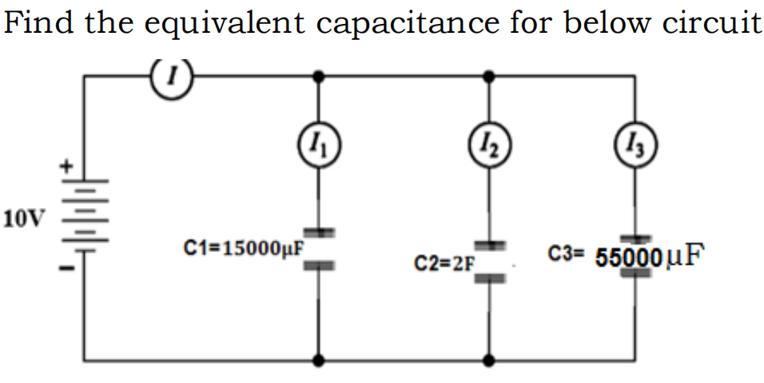/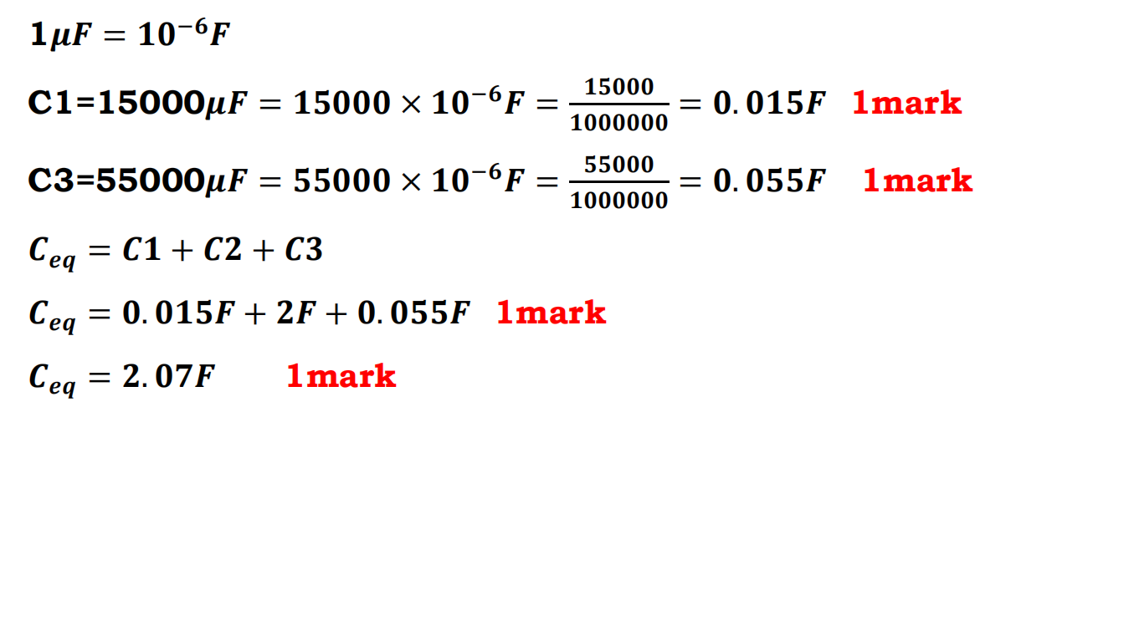

Q8.Find the total resistance for below circuit of reistors:

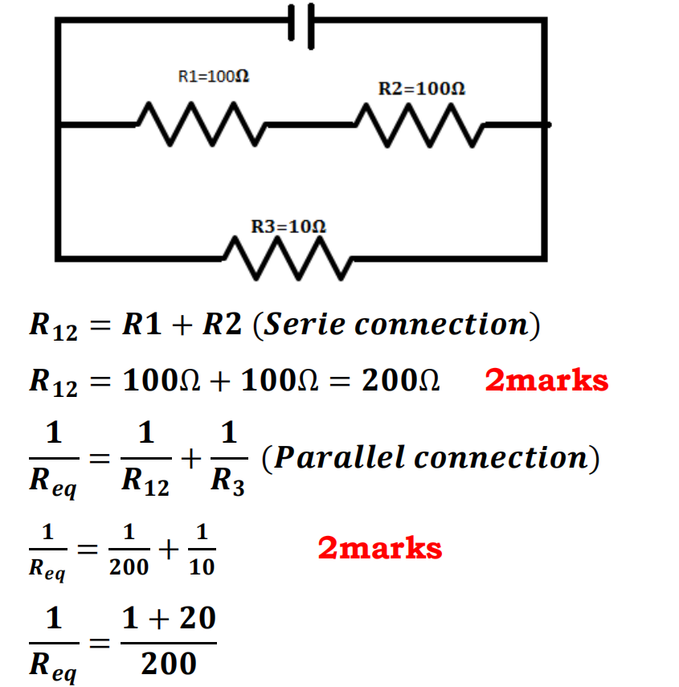

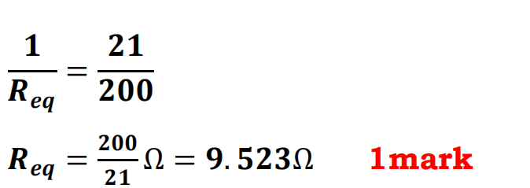

Q9.Calculate the equivalent inductance for inductor connected as

below: 5Marks

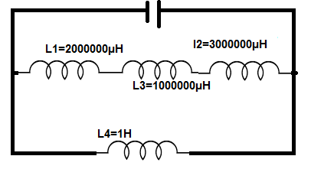

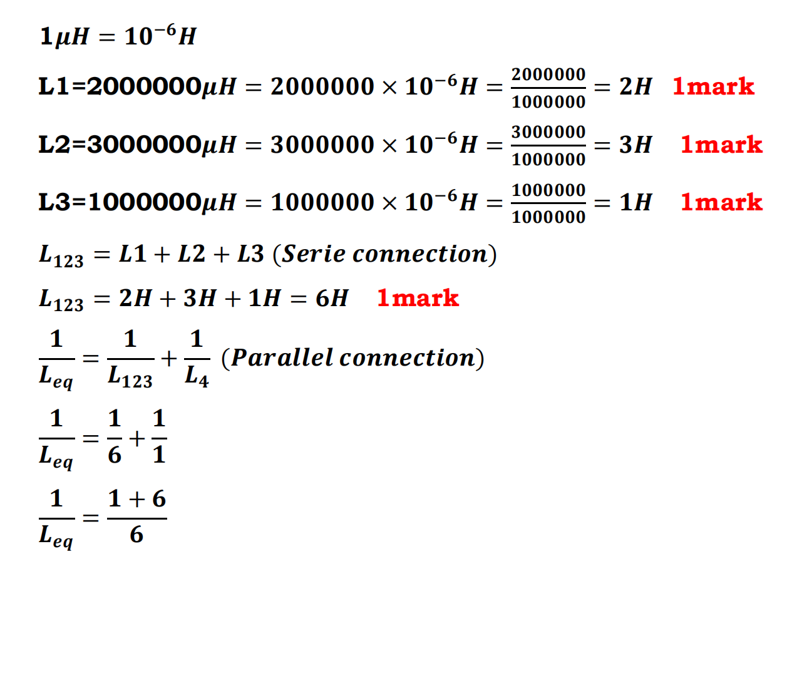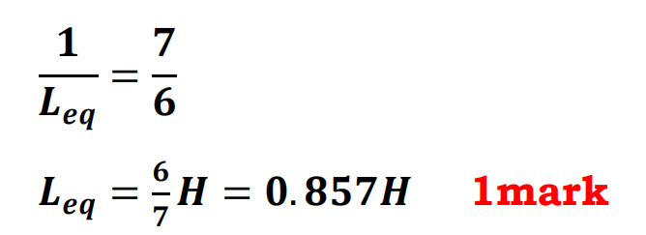

Q10.Identify 5application of diode in photo detection **/each 0.5mark**

* • **Bar code scanning**
* • **Disaster detection**
* • **Character recognition circuit**
* • **Fire detection**
* **Used in detection circui**

Q11.Identify the current in and the voltage drop across each resistor for the following circuit.

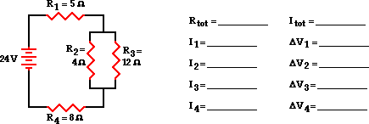

1 / Req = 1 / R1 + 1 / R2 + 1 / R3 ...

1 / Req = 1 / (4 Ω) + 1 / (12 Ω)

1 / Req = 0.333 Ω-1/

Req = 1 / (0.333 Ω-1)

Req = 3.00 Ω

Rtot = R1 + 3 Ω + R4 = 5 Ω + 3 Ω + 8 Ω

**Rtot = 16 Ω/2marks**

Itot = ΔVtot / Rtot = (24 V) / (16 Ω)

**Itot = 1.5 Amp**

Itot = **I1 = I4 = 1.5 Amp**

ΔV1 = I1 • R1 = (1.5 Amp) • (5 Ω)

**ΔV1 = 7.5 V**

ΔV4 = I4 • R4 = (1.5 Amp) • (8 Ω)

**ΔV4 = 12 V**

**ΔV2 = http://www.physicsclassroom.com/Class/circuits/rdbddelta.gifV3 = 4.5 V/2marks**

I2 = ΔV2 / R2 = (4.5 V) / (4 Ω)

**I2 = 1.125 A**

I3 = ΔV3 / R3 = (4.5 V) / (12 Ω)

**I3 = 0.375 A/1mark**

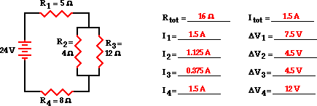

Q12.**A 10 μF, 20 μF, 22 μF, and 100 μF capacitor are in parallel. The total capacitance is**

1. 2.43 uF
2. 4.86 uF
3. 100 uF

4.152 uF

**Answer : 4 /2marks**

Q13.The two type of BJT transistor are: **NPN and PNP transistors/2marks**

: what is the formula of frequency?

**Answer:**

**Q14.formula of frequency is:/3marks**

**where f=frequency**

**T=period**

**Q15. Variable resistors:**means that a resistor can change its resistance value through the control of a person or Itself. /1.5marks

**Fixed resistance** :means that it cannot change its value. The fixed resistance has only one value and never changes (except through temperature, age  etc….)/1.5marks

**II . SECTION B CHOOSE 3 QUESTIONS**

**Q16**.Three inductors of 60mH, 120mH and 75mH respectively, are connected together in a parallel combination with no mutual inductance between them. Calculate the total inductance of the parallel combination in millihenries (mH)/10marks

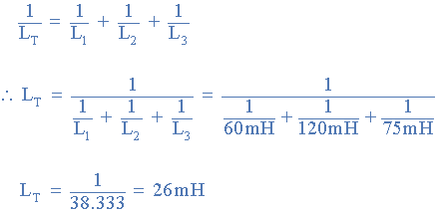

Q17.

Figure below shows that a silicon transistor with β = 100 is biased by base resistor method. Draw the d.c. load line and determine the operating point/10marks

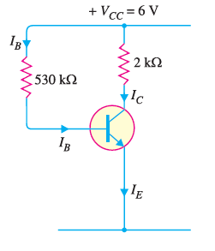.

As it is a silicon transistor, therefore, VBE = 0.7V. Referring to Fig. it is clear that

[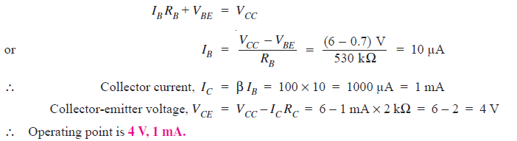](https://electronicspost.com/wp-content/uploads/2019/07/209.png)

shows the operating point Q on the d.c. load line. Its co-ordinates are IC = 1mA and VCE= 4V.

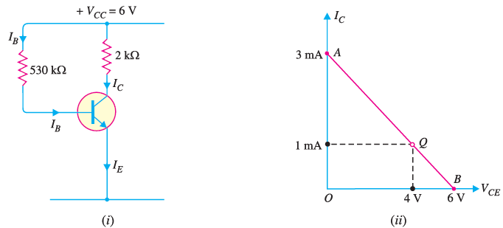

Q18.Find the total capacitance of the combination of capacitors shown in Figure below. Assume the capacitances in the given Figure are known: (C1 = 1 µF, C2 = 5 µF, and C3 = 8 µF)

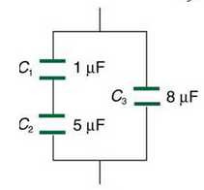

Since C1 and C2 are in series, their total capacitance is given by

Entering their values into the equation gives/4marks



Inverting gives CS = 0.833 µF. /4marks

This equivalent series capacitance is in parallel with the third capacitor; thus, the total is the sum

Ctot=CS+CS =0.833μF+8.000μF =8.833μF/2marks

.

Q19.**.**In the circuit diagram shown in Fig. (i), if VCC = 12V and RC = 6 k, draw

the d.c. load line. What will be the Q point if zero signal base current is 20μA and β= 50 ?/10 marks

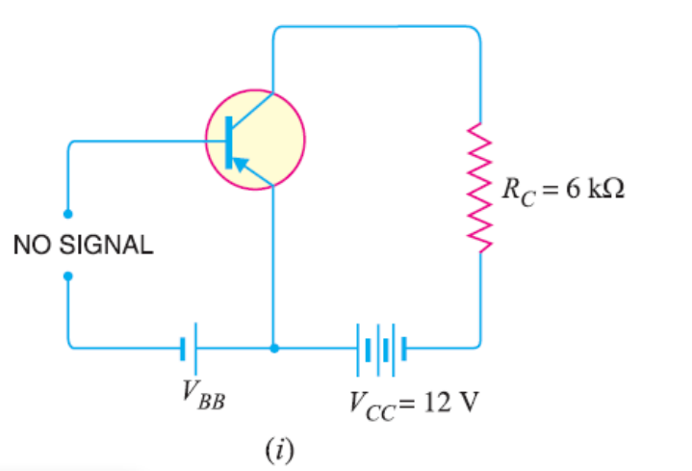

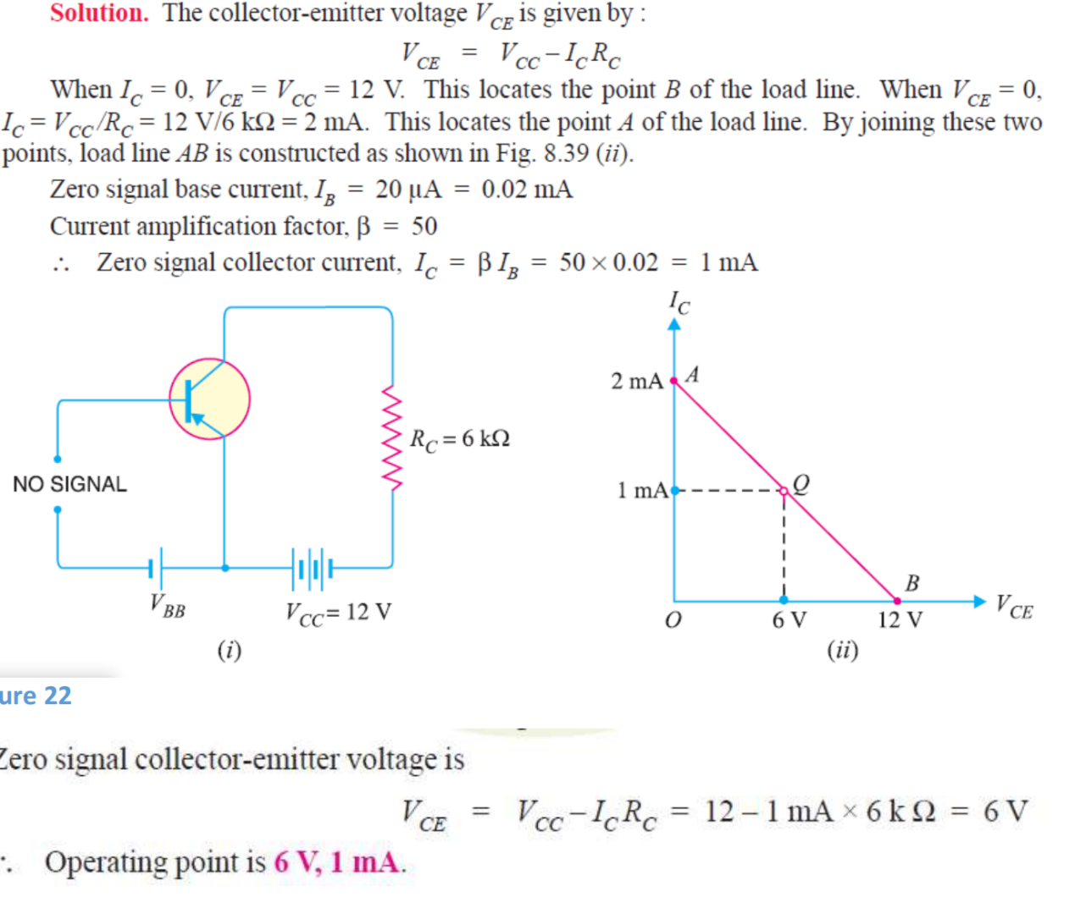

Q20.

1.High input impedance/2marks each

**2 .**Small size,

3.Long life,

4.High frequency response,

5.Low noise,

6.Better thermal stability,

7.High power gain,

8. A high immunity to radiations,

**III SECTION C CHOOSE 1 QUESTION**

**Q21.In For** a transistor, β= 45 and voltage drop across 1kῼ which is connected in the

collector circuit is 1 volt. Find the base current for common emitter connection

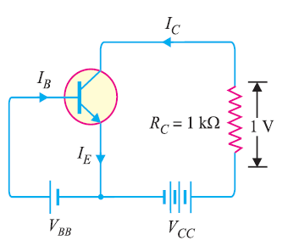

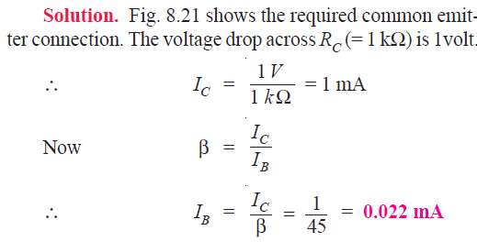

Q22.For the common base circuit shown in

determine IC and VCB. Assume the transistor to be of silicon

